Data Dictionary
RLS-Enabled Regional Sales & Profit Analytics — Power BI Project
This table lists every column in the Orders table (Superstore dataset) used in the data model, along with its data type and a plain-language description of what it represents.
Column Name | Data Type | Description
Row ID | Whole Number | Unique sequential identifier for each row (line item) in the dataset.
Order ID | Text | Identifier for a customer order. One order can span multiple rows, since an order may contain several products.
Order Date | Date | Date the order was placed.
Ship Date | Date | Date the order was shipped to the customer.
Ship Mode | Text (Category) | Shipping method used for the order (e.g., Standard Class, Second Class, First Class, Same Day).
Customer ID | Text | Unique identifier for a customer.
Customer Name | Text | Full name of the customer who placed the order.
Segment | Text (Category) | Customer segment the order belongs to (Consumer, Corporate, or Home Office).
Country | Text | Country associated with the order/delivery.
City | Text | City associated with the order/delivery.
State | Text | State or province associated with the order/delivery.
Postal Code | Text | Postal/ZIP code of the delivery location.
Region | Text (Category) | Sales region the order falls into (e.g., North, South, East, West, Central).
Market | Text | Broader market grouping the order belongs to.
Product ID | Text | Unique identifier for the product ordered.
Category | Text (Category) | Top-level product category (Technology, Furniture, or Office Supplies).
Sub-Category | Text (Category) | Product sub-category within a Category (e.g., Phones, Chairs, Binders).
Product Name | Text | Name of the product ordered.
Sales | Decimal Number | Total sale amount (revenue) for the line item, in local currency.
Quantity | Whole Number | Number of units of the product ordered in the line item.
Discount | Decimal Number (%) | Discount rate applied to the line item, expressed as a decimal (e.g., 0.10 = 10%).
Profit | Decimal Number | Profit earned on the line item; negative values indicate a loss.
Shipping Cost | Decimal Number | Cost incurred to ship the line item.
Delivery Days | Whole Number | Calculated column: number of days between Order Date and Ship Date.
Loss/Profit Flag | Text (Calculated Column) | Calculated column that flags each line item as "Profit" or "Loss" based on the sign of the Profit value.

Notes
• Zone and DateTable are separate lookup tables in the model (not part of Orders): Zone holds Region and Region Manager for RLS; DateTable holds the Date column used for time-based calculations.
• The six DAX measures built on top of these columns (Total Sales, Total Profit, Profit %, Total Orders, Discount %, Avg Delivery Days) are documented separately in the DAX Formula List.
• Data types above are inferred from column names and the Model view icons (Σ = numeric, calendar = date, plain = text). Please cross-check each against the actual column properties in Power Query / Model view before submitting, in case any differ (e.g., Postal Code is sometimes stored as text even though it looks numeric).

DAX Formula List
RLS-Enabled Regional Sales & Profit Analytics — Power BI Project
The table below lists every measure built in the data model, the table it belongs to, its data type, and the full DAX expression used to calculate it.
Measure Name | Table | Data Type | DAX Expression
Total Sales | Orders | Number | SUM(Orders[Sales])
Total Profit | Orders | Number | SUM(Orders[Profit])
Profit % | Orders | Number | DIVIDE([Total Profit], [Total Sales])
Total Orders | Orders | Integer | DISTINCTCOUNT(Orders[Order ID])
Discount % | Orders | Number | AVERAGE(Orders[Discount])
Avg Delivery Days | Orders | Number | AVERAGE(Orders[Delivery Days])

Notes
• Profit % references two other measures (Total Profit, Total Sales) rather than raw columns, so it recalculates correctly at any filter level (category, region, customer, etc.).
• Total Orders uses DISTINCTCOUNT on Order ID rather than a simple row count, since a single order can span multiple line items in the Superstore dataset.
• Discount % and Avg Delivery Days are both averages across all order line items, giving a book-wide rate rather than a per-order total.

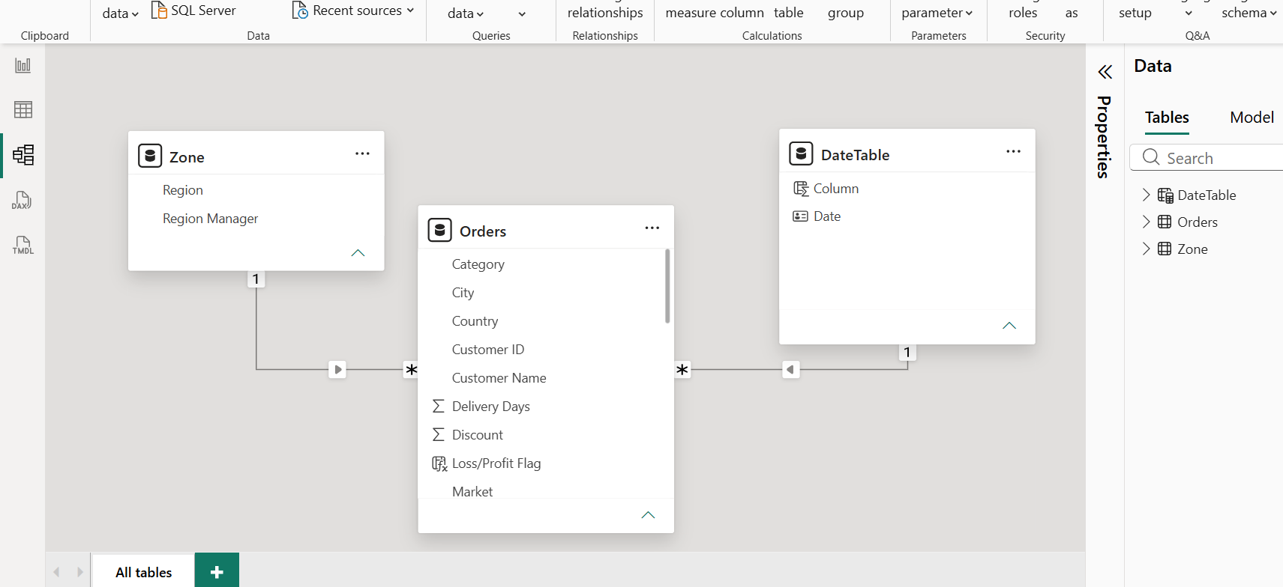

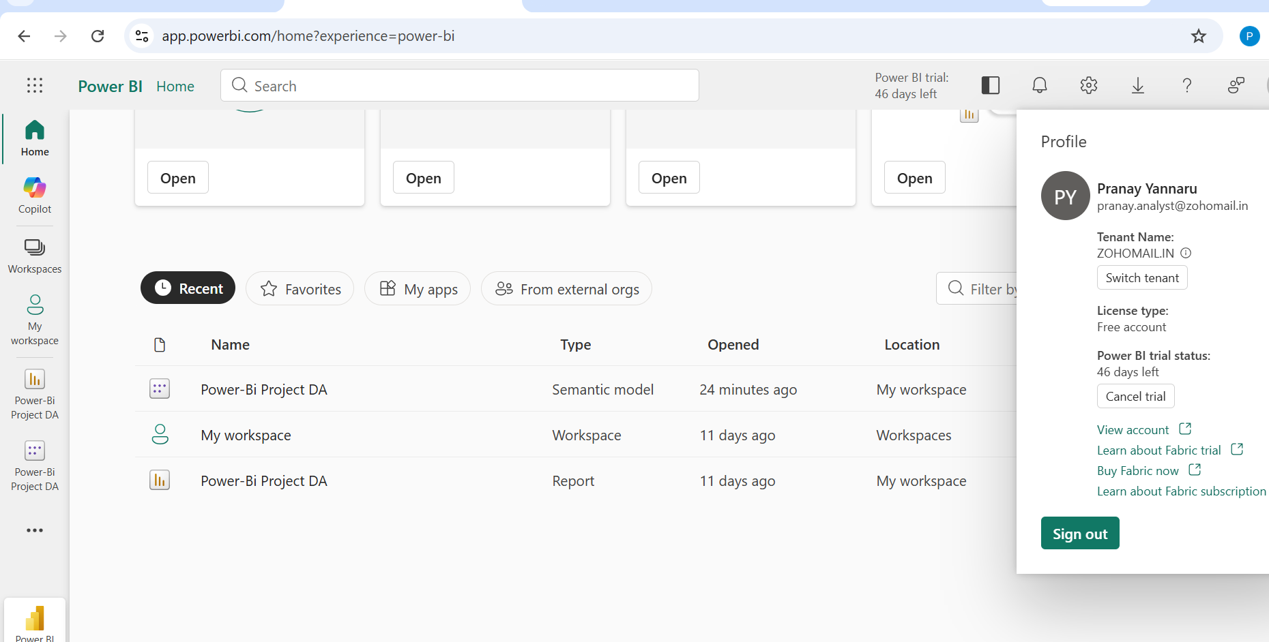

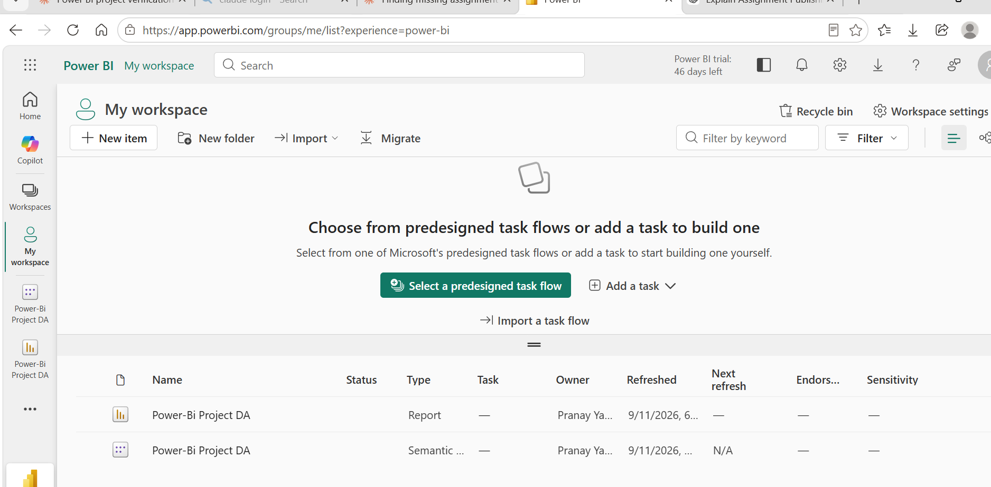

Conclusion:

The Power BI dashboard gives an overall view of sales and profit performance across different categories, customers, products, and regions. It helps users easily understand sales trends, compare the performance of different regions, identify important customers and products, and analyze how discounts can affect profitability.

The interactive features of the dashboard make it easier to explore the data and view information at different levels of detail. Row-Level Security (RLS) helps provide secure access to regional data, while bookmarks, drill-through pages, and customized tooltips make the report more interactive and user-friendly.

Overall, this project shows how Power BI can be used to transform retail data into useful business insights. The dashboard provides an interactive and secure reporting solution that can help users understand business performance and support data-driven decision-making.

